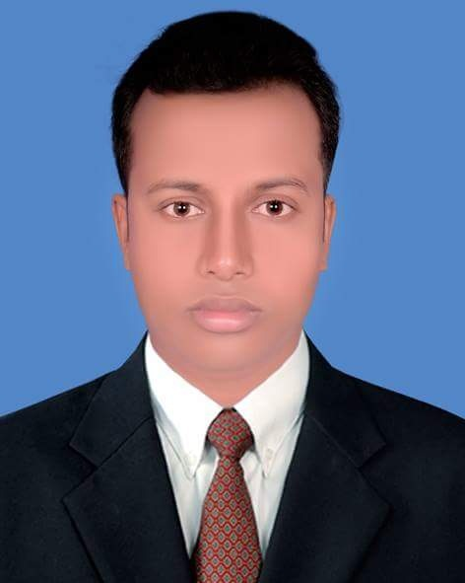
Md. Salman Prodhan

H#01, R#07, Sector#13,Uttara-1230, Dhaka
Contact: 01744-947107
Email: salmanprodhan3@gmail.com

Professional Summary
A competent Electrical Engineer with a comprehensive knowledge of designing, developing and maintaining electrical systems and components to required specifications, focusing on economy, Safety, reliability, quality and sustainability. A consistent track record of successfully completing projects from the concept and detail of the design, maintenance, operations through to implementation, testing and handover.

Professional Experience
- Design Engineer at Technological services limited Science Jan-2018 to present.
- Sub-Assistant Engineer at BREB Consultants work under 26-Dec-2012 to 31-Dec-2017 ( since 5 Years).

Responsibility
- AutoCAD layout/ Section view drawing of high voltage substation 11 KV to 33 KV
- HT & LT Line Design and construction.
- Reading electrical Design Specifications and technical drawings.
- Preparation of Electrical procedures for installation, testing & commissioning of high voltage substations.
- Preparation cable schedule for substation equipment wiring.
- Operation of shielding protection, rigid Busber Earthing, Indoor and Outdoor lighting of substations.
- Attending meetings to solve any technical issues.
- Maintenance and Operations Industrial Machineries.
- Generator Maintenance and Operations.
- PFI Panel, DB, SDB Board Operations.

B.Sc (Bachelor of Science)
Institute : Atish Dipankar University of Science & Technology.
Subject : Electrical & Electronic engineering.
Passing Year : 2017
Result : 3.01 (out of 4)
University : Atish Dipankar University of Science & Technology.

Diploma in Engineering (Diploma)
Institute : Bogura Polytechnic Institute, Bogura.
Group : Mining & Mine Survey Technology.
Passing Year : 2012
Result : 3.51 (out of 4)
Board : BTEB

Secondary School Certificate (S.S.C)
Institute : Bhatgram High School & College.
Group : Science
Passing Year : 2008
Result : 4.44 (out of 5)
Board : Rajsahi

Training Experience
Training Institute : Maddahpara Granite Mining Company Ltd.
Training time : Industrial 6th Months.
Training Institute : Jamalpur Polly Biddut Somity.
Training time : Industrial 4th Months.

Language Known
Bengali: Excellent command over reading, Speaking and writing.
English: Good command over reading, Speaking and writing.

Computer Skills
  - MS word, MS Power Point, MS Excel, Internet & Browsing.
  - Auto cad, Drafting.
Aditional Information
Date of birth : 01-03-1993 Nationality : Bangladeshi
Religion : Islam Marital Status : Married
District : Gaibandha
Declaration: I do hereby declare that particulars provided in the resume are true to the best of knowledge and belief.


Md. Salman Prodhan

Date:

